|  |  |  |  |  |  |
| --- | --- | --- | --- | --- | --- |
| Date | 2-Dec-22 | | | Tester Name | Shahabuddin Syed |
| Environment | Penfax - Test | | | Login used |  |
| Operating System | Select OS | Version: | Update: | | |
| Software Used | Select Software | Version: | Update: | | |
| Select Software | Version: | Update: | | |
| Release version | 22.4.1 | | | | |
| Title | E21.04 | | | | |
| Test Type | Regression | | | | |
| Test Scenario | Print off a T4 for a member(small pension payment) | | | | |
|  |  | | | | |
| Expected Results |  | | | | |
| Pass/Fail | Pass | | | JIRA# | N/A |

Describe your steps with screenshots:

Search for an active member in the PEPP Plan

Click on People  
Do a Member Search  
Select PEPP for Plan  
Click Search  
Click on the Stakeholder ID of one of the members

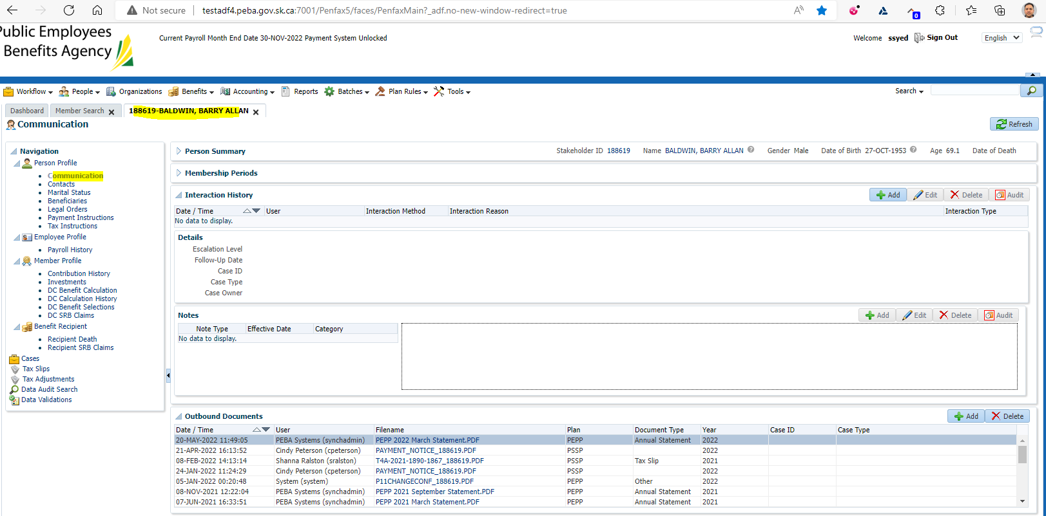

Click on Communications  
Under Outbound Documents Click on one of the Filename's  
You may need to select open depending on the browser

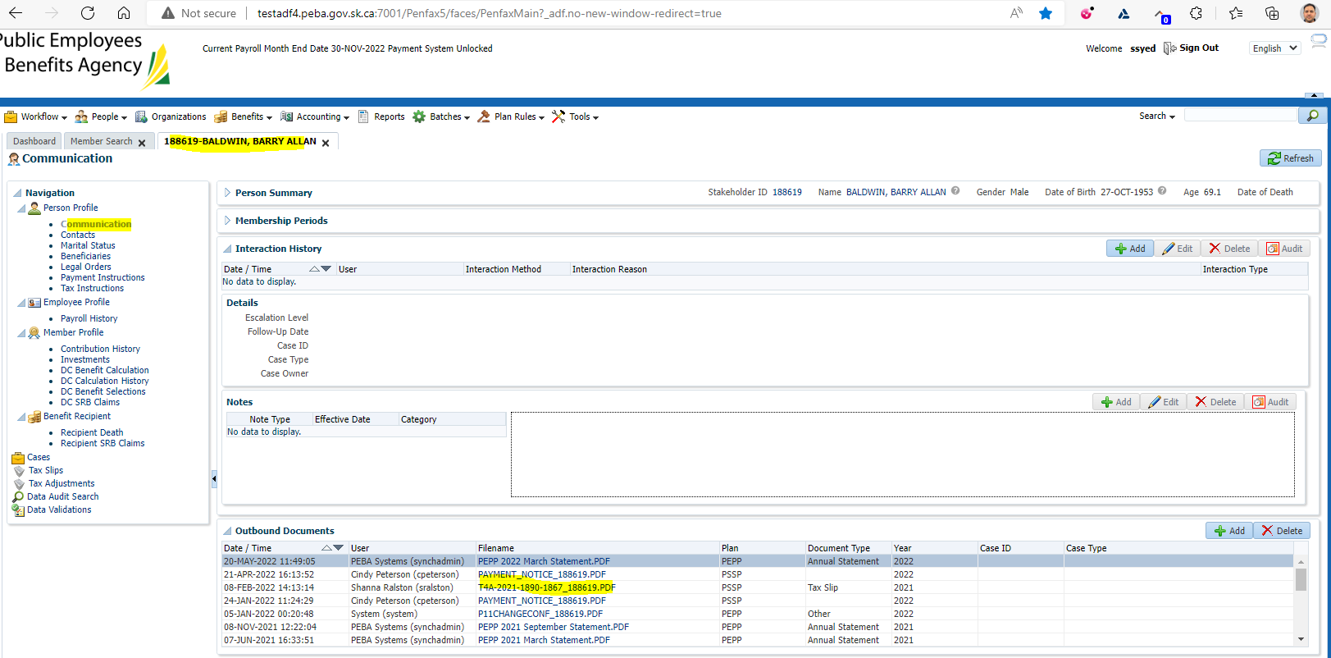

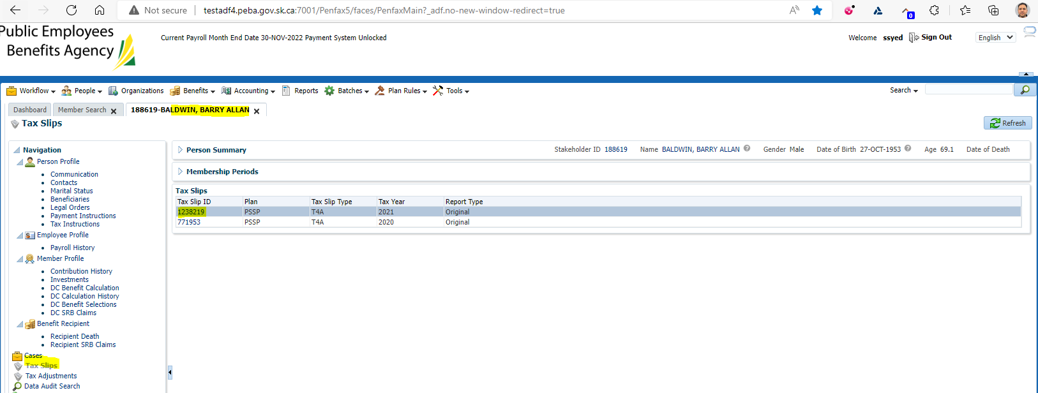

In case if we don’t find a member need to create one

Need to run a Small Pension payment or can use if found a member

Steps in order to create a small pension payment

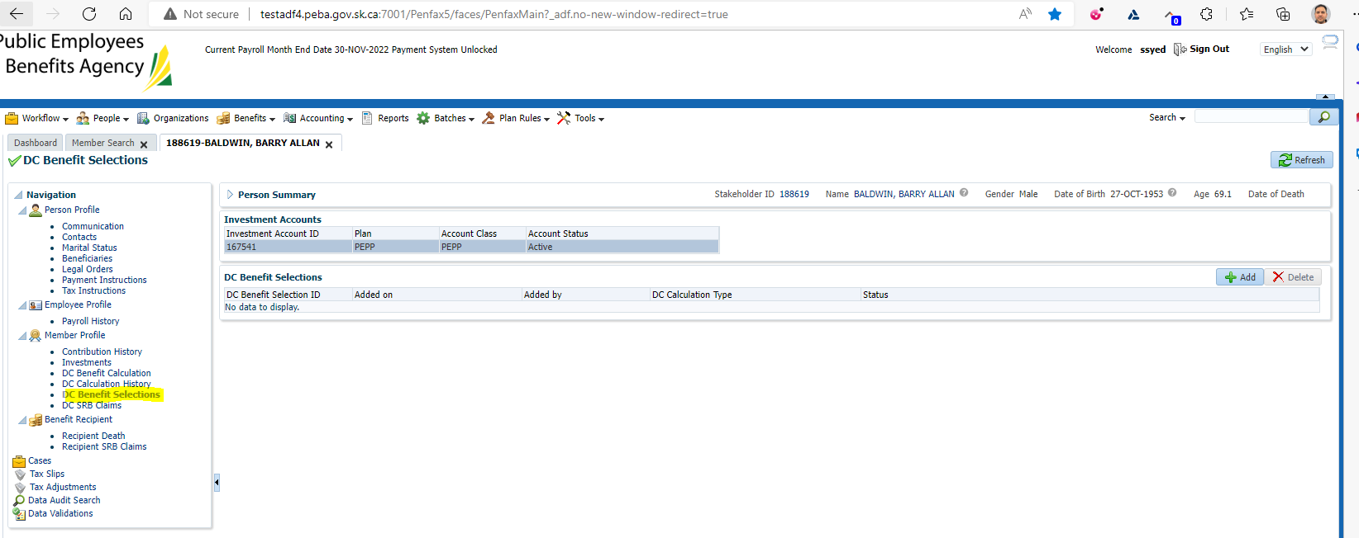

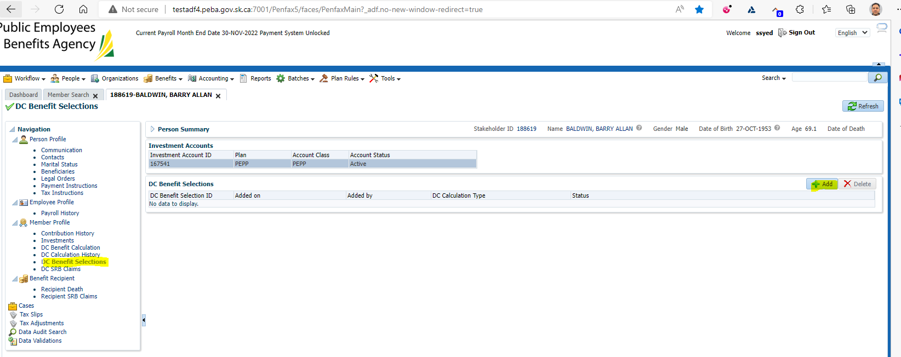

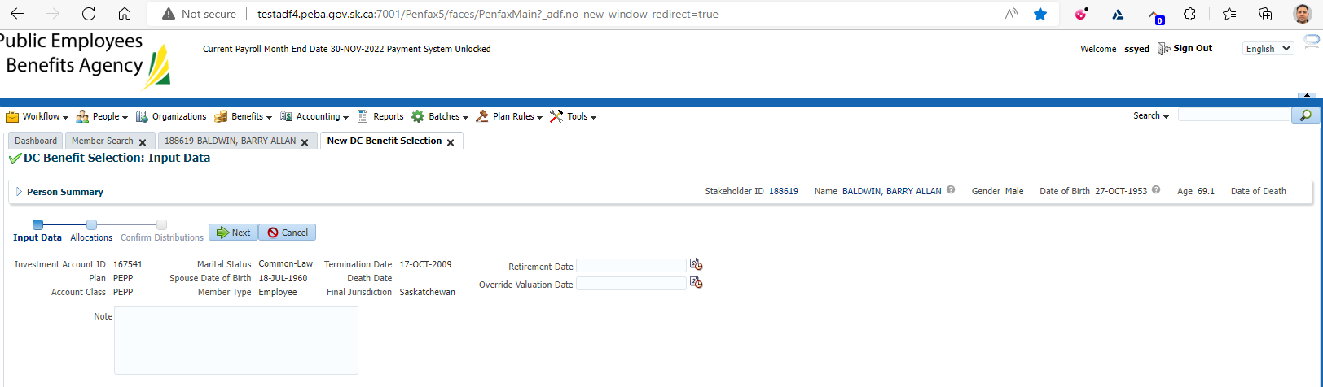

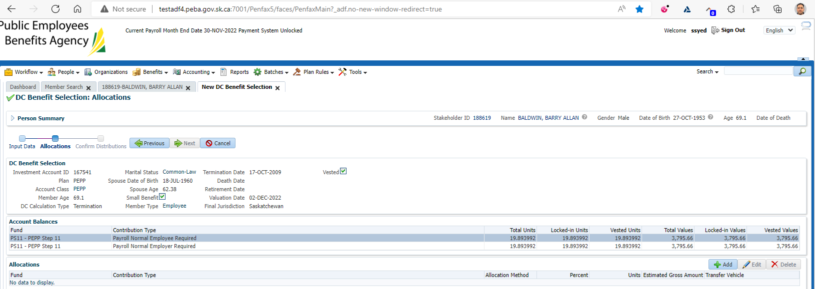

Click on Add under Allocations

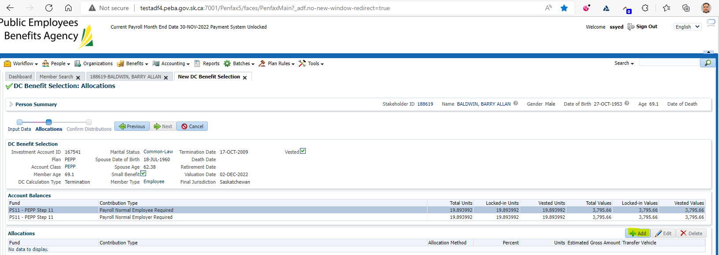

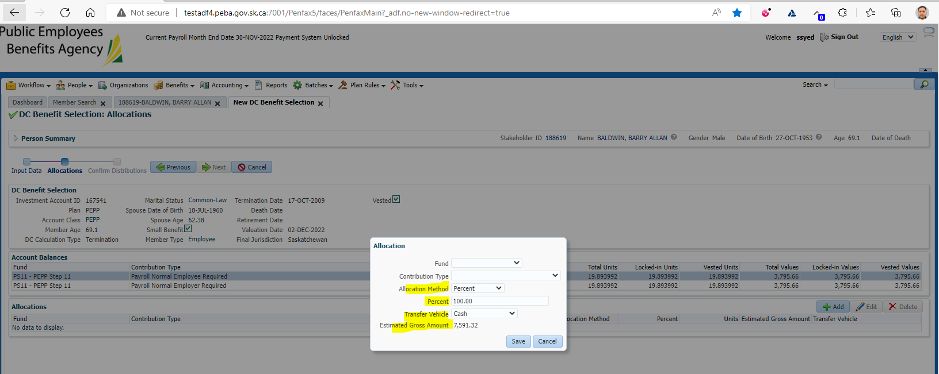

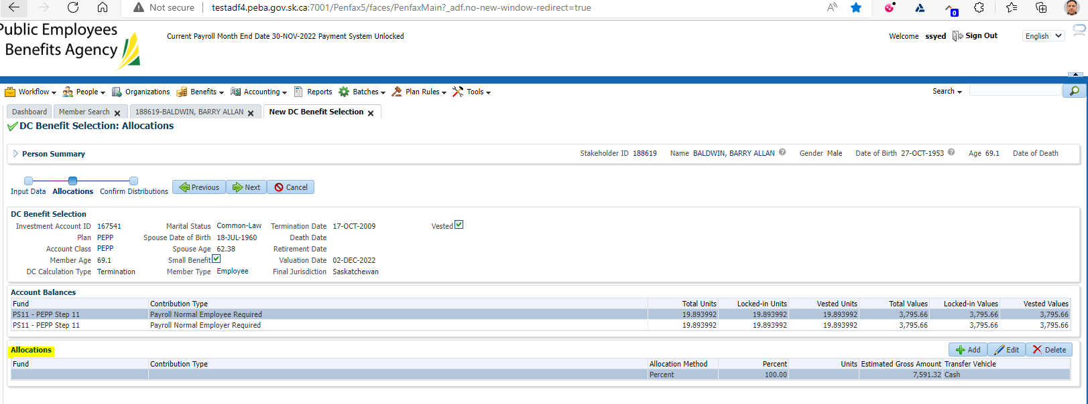

Click Next on the train

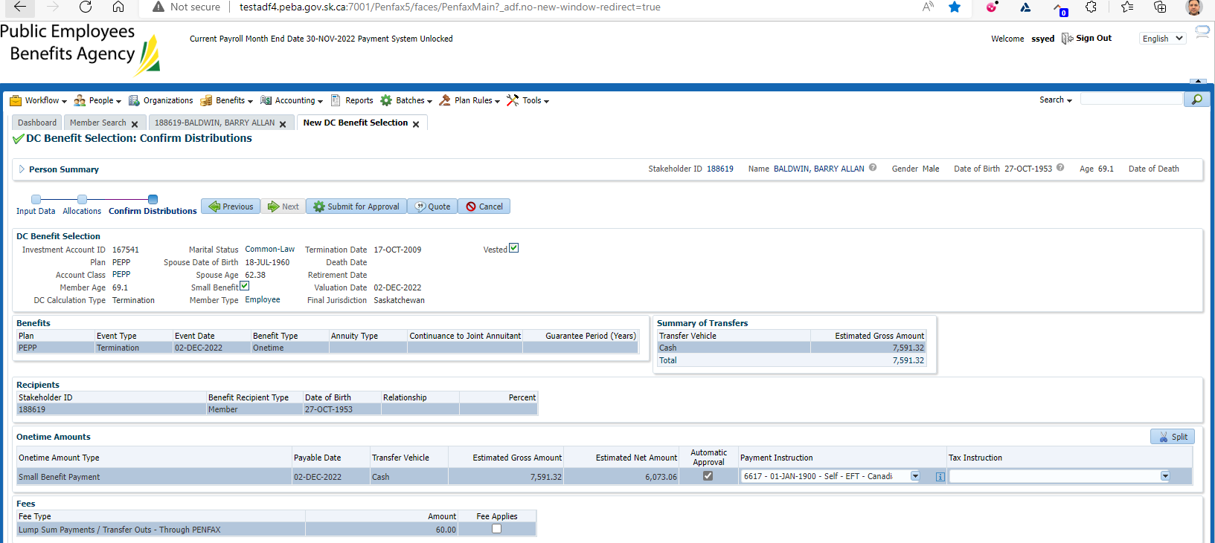

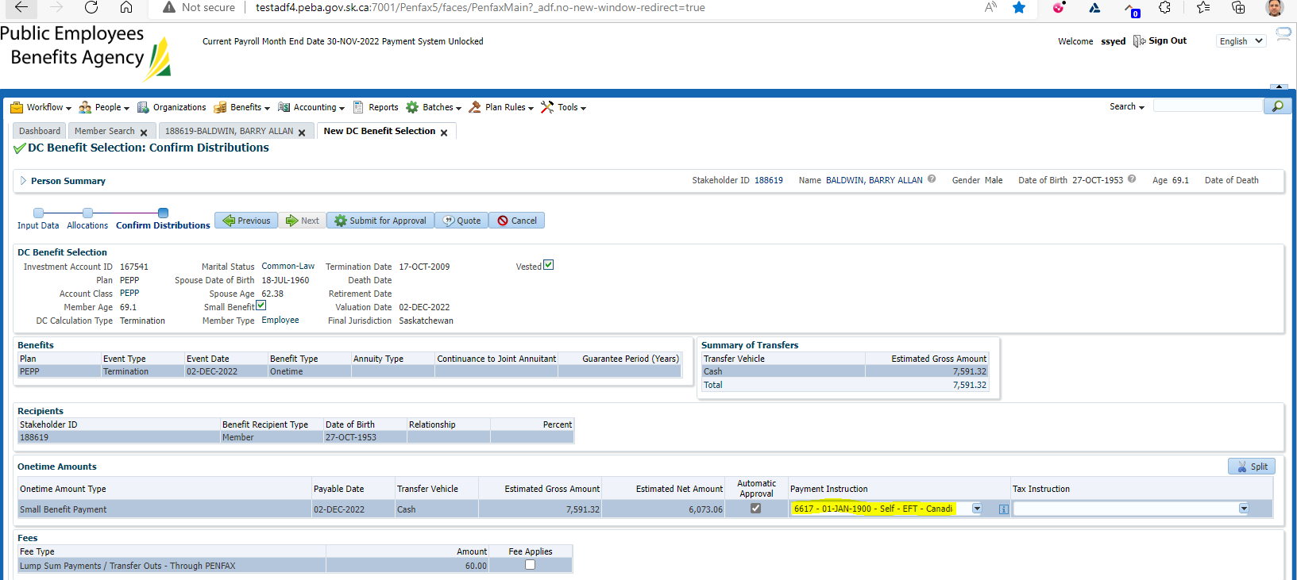

Click on Submit for Approval

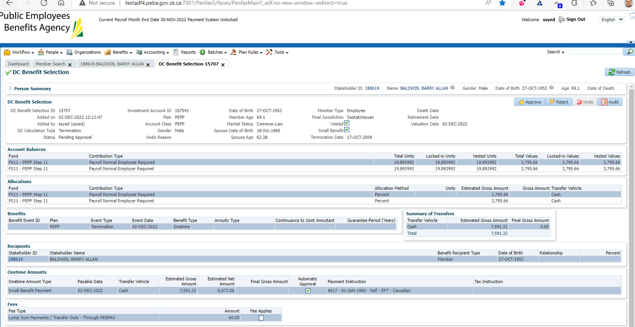

Click on Approve

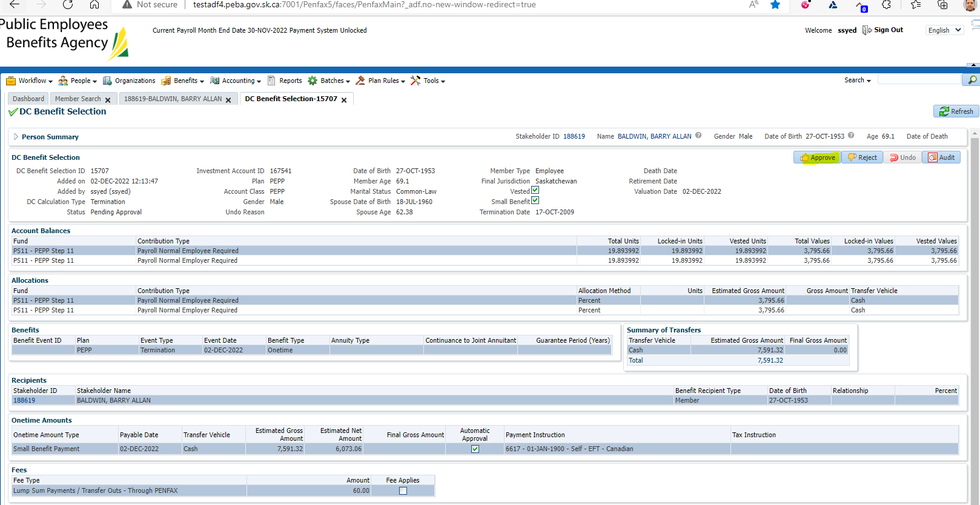

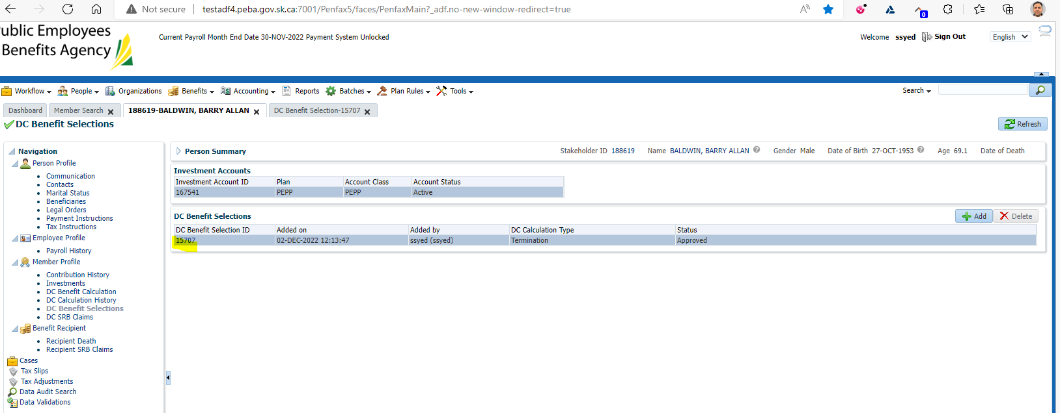

Note: If the Small Pension Payment was taken in cash, a T4A **Tax Slip** will be issued at the end of the year and saved under the **Navigation** menu, **Tax Slips** screen.

Need to click on the latest doc under Outbound Documents

On the right-hand side, it will appear under Downloads

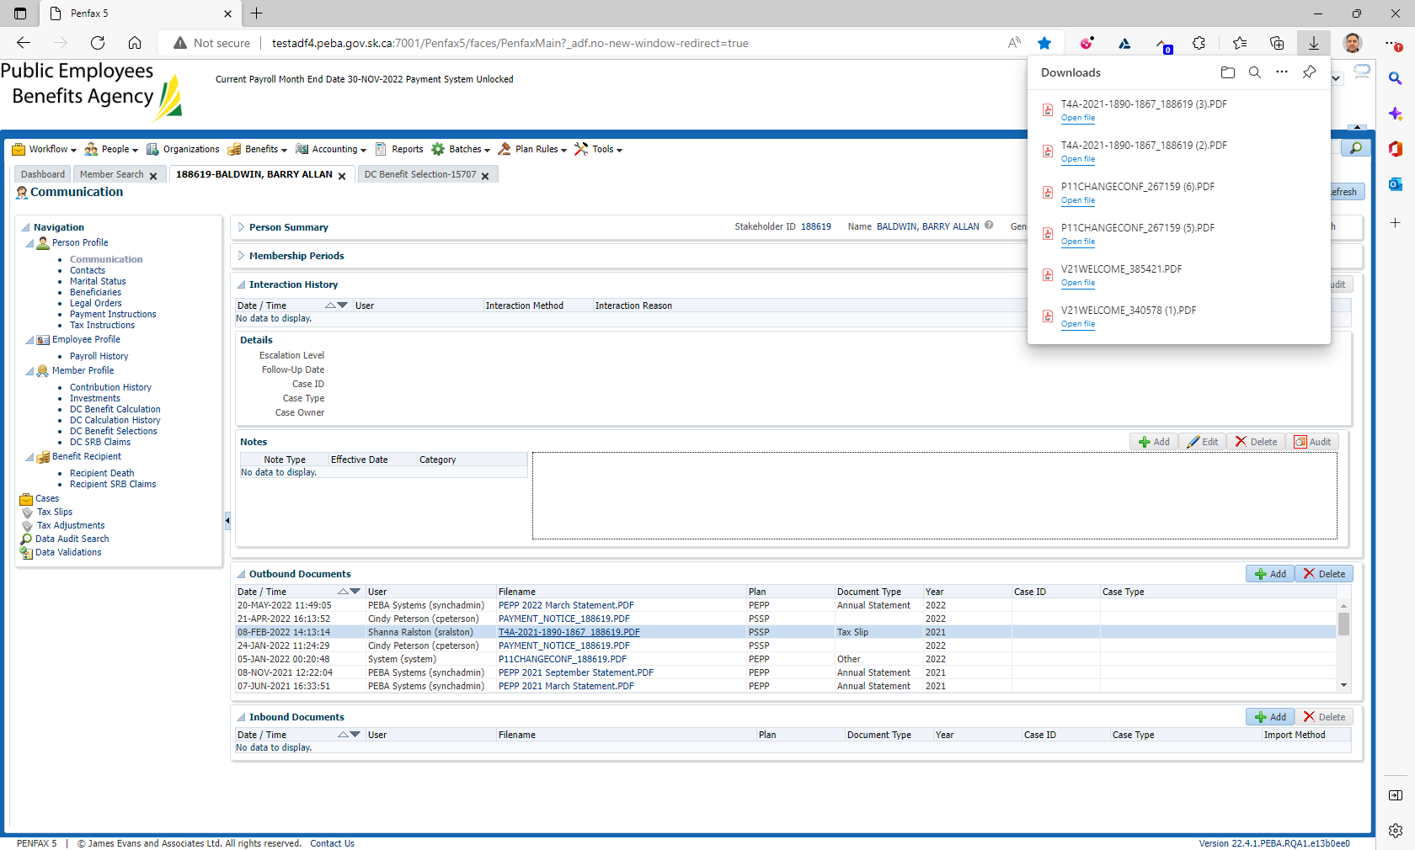

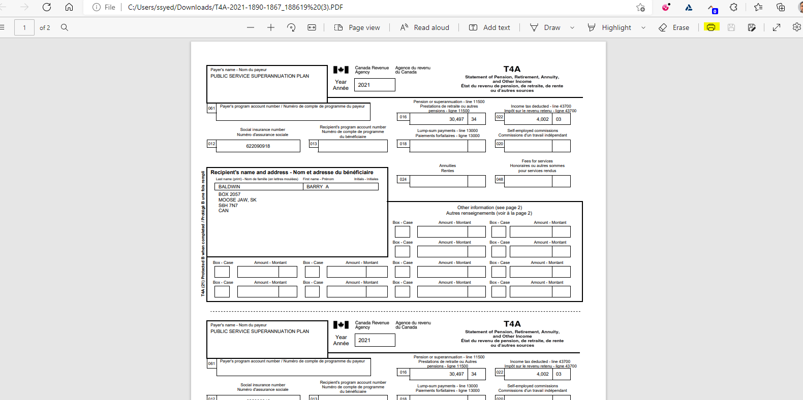

Print the file off how you would normally. It will open the file type of whatever was saved

Opened as PDF with option to print

